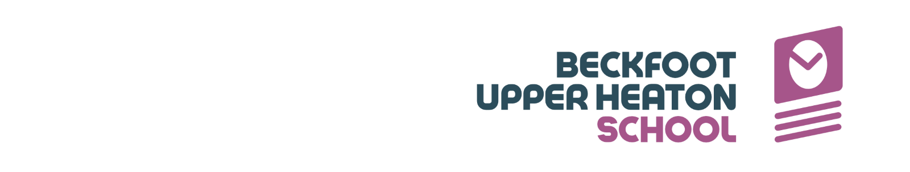
Local Behaviour Protocol
Our school values are ‘Excellence, Integrity and Kindness’. They underpin our school sentence, ‘The school taught students to act with integrity and kindness so they went on to demonstrate excellence in their chosen field; it was a place where all belonged’
We foster a welcoming culture of safety, responsibility, and respect ensuring a positive climate where all members of our school communities feel safe, comfortable, and accepted.
This protocol has been developed in conjunction with the whole school community and should be read alongside the Beckfoot Trust Behaviour Policy which is available on the Trust website: Beckfoot Trust - Policies and Documents. The protocol details specific processes within our school.
This protocol explains how we instil the five ‘Learning Habits’ at Beckfoot Upper Heaton.
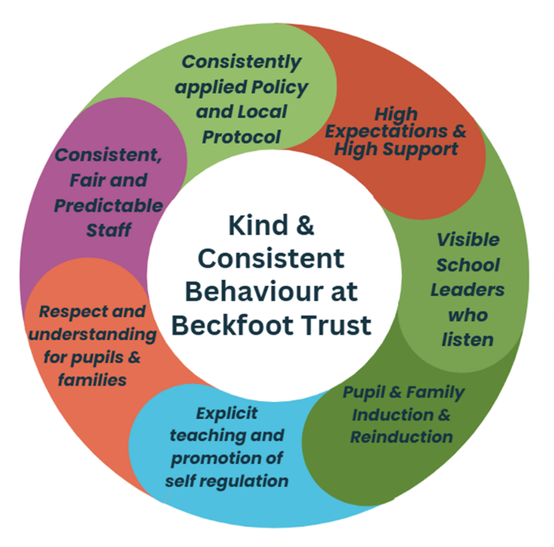
- Consistently applied policy and local protocol
Our Trust Policy sets out clear expectations for leaders and staff within our school to ensure positive behaviours are displayed so all pupils can feel safe and learn.

Our local behaviour protocol reflects our high expectations of students at Beckfoot Upper Heaton (BUH). Emphasis is placed on providing students with ‘chance’ and ‘choice’ before a consequence is reached. We narrate the positives through rewards and celebrate when students meet or exceed our expectations.

We value staff development, ensuring a robust cycle of staff training is delivered across the academic year. Time is allocated on training days to revisit the behaviour protocol and ensure a common understanding of the principles amongst all staff in school. ClassCharts data is regularly monitored throughout the day. ClassCharts data is used to reward and motivate and engage our students. We actively encourage all families to download the ClassCharts App as this is our preferred school communication platform.

To ensure that no child is left behind, behaviour data is analysed to inform all members of the team around the child. Student behaviour is ‘live’ and ever changing, therefore the support strategies used for our students are reviewed in line with collated data.

- High expectations and support for all
At Beckfoot Upper Heaton, we expect all students to embrace our learning habits so that all students can learn and make progress in all lessons.

Rewards and Recognition
We expect that our students aim for excellence and focus on being the best version of themselves. We believe that all students are capable of making the right choice and we expect this from them. In acknowledgement of this, each student will be awarded 1000 recognition points at the start of each cycle (September, January, April). Through their actions and application of the ‘learning habits’ they can earn more recognition points to add to their balance. If a student receives Consequence points, they will be deducted from their overall balance. At the end of each term (December, April, July) students will be able to trade their overall balance for reward activities.

R6 | Special Reward (Golden Ticket events – Theme Park/Theatre)
R5 | Internal rewards (cinema afternoon etc)
R4 | Class Charts Badges/ Vouchers etc
R3 | Certificates/ Letters home
R2 | Praise Phone call / Positive Postcards
R1 | Precise Praise/Praise Points

Students will receive badges for 100% attendance and will be eligible for the different reward badges shown below*
Gold
Average ATL Score 1 plus 100% attendance
Silver
Average ATL score 1 plus 95% attendance
Or
Average ATL score 2 plus 100% attendance
Bronze
95% attendance
Or
Average ATL score 2 or higher

*discretionary reasonable adjustments will be made on an individual basis, as we recognise that our students have individual needs and differences.

Subject awards
Students excelling in each subject area and those striving to improve, will also be rewarded for their efforts in a half-termly rewards assembly. Each subject will nominate one student for attainment and one student for effort in each year group. Students who go above and beyond in their subject area can be nominated as subject ambassadors, receiving a pin badge and representing their chosen field at prestigious events.

Learning habits and Core values
Our aim is to develop independent, self-regulated and resilient learners. To achieve this, it is essential that our students consistently demonstrate the following five learning habits.

Our learning habits were purposefully crafted to ensure that our students experience of school is rooted in our values of excellence, integrity and kindness.

Learning Habit 1 – Punctuality and attendance
Be on time and attend school everyday
Learning Habit 2 – Uniform
Always wear your uniform correctly and with pride
Learning Habit 3 – Equipment
Bring all the necessary items for your lessons
Learning Habit 4 – On Task Behaviour Classroom
Stay focussed and do your best in every activity
Learning Habit 5 – On Task Behaviour Community
Be respectful and kind in your interactions

Learning Habit 1: Punctuality and attendance

The school gates open at 8.00am
Students are expected to arrive before 8.15am so that they can join line-up and be ready to start the day at 8.15am. The main school gate will close at 8.15am. Students who arrive after this will be classed as late and they will receive a C2 code. If a student receives 3 or more C2 codes for being late to school in a week, a letter is sent to their parents.

The school register closes at 8.50am. If students arrive after this, they will receive an unauthorised absence for the morning session. A student who has 10 or more unauthorised absences in a rolling 10-week period, may be issued a fine from the local authority.

Each morning and after social times, students are expected to line up in their tutor groups in their designated area (Y7-9 only). Line up is pivotal to the start of our school day to promote a sense of belonging. Positive framing is used to communicate achievements from the previous day, reinforce expectations for the day ahead, and check student wellbeing. This consistent approach ensures students are calm, settled, and ready to learn, whilst embedding the habitual process required for success at Ks4 (Y10-11). By year 10 students no longer require the line up process as they have the tools to self-regulate and take ownership of their learning.

During the changeover of lessons, students are expected to move calmly with pace and purpose and to walk on the left, to ensure they arrive at lessons promptly. Students who are late to lessons after the bell will receive a C2 late to lesson code (unless they have a note from a staff member).

Students who are significantly late to lessons will be classed as truanting, unless they have a note from a member of staff. Students on corridors after this time without a valid reason will be taken to the R&R (Reflection and Restorative) room until the end of the next social time.

Learning Habits 2 and 3: Uniform and Equipment

We expect all students to be in full uniform every day and to have all their equipment in a school bag, so they are ready to learn.

Students who do not have the correct uniform will have the opportunity to borrow the correct uniform from the school. Students with incorrect uniform will be given a C2. If they receive 3 or more C2 for borrowing uniform in a week, a letter will be sent home to parents.
If a student refuses the ‘Choice’ to borrow uniform, they will be taken to R&R and issued a C4 for Defiance. Students will remain in R&R for a minimum of 2 lessons plus 1 social time or until they agree to change their uniform or the missing unform is brought into school from home. Items that should not be worn will be confiscated and will need to be collected at the end of the school day.

Learning Habit 4: On Task Behaviour Classroom

C1  Not logged | 1st Verbal warning (Chance) | Verbal chance given to student to correct behaviour
C2  Logged | 2nd Verbal warning (Choice) | Verbal choice given to student to correct behaviour (logged)  *Incomplete homework is C2 but no correction
C3  Logged | Correction (Consequence)  15-30 min range | Student failure to make positive choice – consequence: On-call to remove to Reset Room
C4  Logged | Correction (Consequence)  30-60 min range | Student failed to make positive choice in Reset Room – consequence: time extended, and student moved to Reflection Room
C5  Logged | R&R | Student failed to make positive choices in R&R following 2 warnings (W1, W2), W3 in RR is potential fail or more serious consequence decided by SLT

*Reset Room – If a student reaches a C3, On-call staff will collect from their lesson and
escort to the reset room. Students are expected to complete work whilst in the room and
will remain in Reset until the end of their next social time. Any students escorted to Reset
Room during period 5 will receive a 30-minute afterschool correction.
If a student fails to
comply to the rules of the Reset Room, this is logged as a C4 and On-call will collect the
student for R&R.

Please note that some doors in school, such as external doors and rooms are maglock
enabled. This is for health and safety only. In the event of any emergency evacuations all
maglocks are auto released. Weekly tests are carried out to ensure the maglocks are in
good working condition. The maglocks can also be released manually by pressing a
button located next to the door should the need arise in an emergency.

Learning Habit 5: On Task Behaviour Community

C1  Not logged | 1st Verbal warning (Chance) | Verbal chance given to student to correct behaviour
C2  Not Logged | 2nd Verbal warning (Choice) | Verbal choice given to student to correct behaviour (Not logged)
C4  Logged | R&R | Student failed to correct behaviour. Appropriate log in response to the behaviours being displayed.
C5  Logged | R&R | Student failed to make positive choices in R&R following 3 warnings (W1, W2 and W3)

Mobile Phones
We want students to be able to learn without the distraction caused by mobile phones and other electronic devices. The evidence tells us that mobile phones are a significant distraction to young people as both the device and the apps are designed to be addictive. They also undermine confidence and relationship building.

Many young people would rather communicate via a device than in person, which can lead to un-healthy relationships with their peers. Mobile phones have an impact on student’s mental health for many reasons including: increased anxiety, increased distraction, self-image issues, cyberbullying, disrupted sleep patterns and loss of confidence.

Therefore, to support the development of our students:
- Mobile phones, smart watches, and all other electronic devices must not be visible once on school grounds.
- Mobile phones should be turned off, out of sight and inside the student’s bag or pocket.
- Mobile phones seen will be confiscated and placed in the school office. Students will receive a C3 code and a 30-minute after school correction. However, if a student refuses to hand over their mobile phone, they will receive a C4 Defiance code and will be taken to R&R for a minimum of 2 lessons plus 1 social time. Another chance will then be given to hand over their mobile phone.
- 1st time confiscated – end of day alongside a 30-minute correction
- Multiple confiscations – item must be collected by a parent/guardian alongside a 30-minute correction
- Should the issues around mobile phone become persistent and/or it is used to cause issues in school or within the community (eg. misuse through social media platforms), the school reserves the right to take further steps to mitigate such behaviour.

Serious Behaviours
Any serious behaviours will be dealt with in an appropriate manner and will be investigated promptly by the Pastoral team or SLT. Please see Trust Policy for more information.

Policies – Beckfoot Trust

Any serious behaviours will receive an appropriate sanction after the incident has been investigated. This could include time in R&R, a behaviour placement at another school, a suspension or in very serious cases, a permanent exclusion.

All suspensions are at the discretion of the Headteacher.

All C4 and C5 codes will incur a period of time in the reflection room. The reflection room is a silent workspace where students can work independently, focusing on knowledge retrieval. The room is supervised by appropriate number of staff who assist students with their learning and help re-regulate where appropriate. This room is also supervised by pastoral and senior leadership team. Our intentions are to see students in the Reflection Room learn from their mistakes, consider on how they can be more successful and try to improve their behaviour when they return to their normal timetable.

The length of time students spend in R&R is dependent on the behaviours that have been displayed. Students will spend a minimum of two periods plus social time in the reflection room. All C4 and C5 codes will automatically incur time in R&R plus a 30-min after school correction.

Any prohibited items brought onto school grounds will be confiscated and placed in the school safe or secured in a lockable cupboard in a lockable office if it is a large item. If the item is illegal and/or dangerous, the Headteacher will ask a member of SLT or the safeguarding team to make a report to the police. If the item is prohibited and not illegal, there will be a discussion with family about how to return or dispose of it, in line with the family's wishes. Consequences of prohibited items are at the discretion of the Headteacher.

The 3 C’s - Chance, Choice, Consequence

 |  | Learning Habit 1 | Learning Habit 2 | Learning Habit 3 | Learning Habit 4 | Learning Habit 5
 |  | Lesson Punctuality and Attendance | Uniform | Equipment | Learning Behaviours  (Classroom) | Social Behaviours (Community)
C1  Not logged | 1st Verbal warning (Chance) | Late to school each day | Opportunity to correct uniform | Opportunity to purchase equipment in Morning Meeting | Verbal chance given to student to correct behaviour | Verbal chance given to student to correct behaviour
C2  All logged (Not LH5) | 2nd Verbal warning (Choice) | Late to each lesson (after bell) | Opportunity to loan uniform | Failure to be fully equipped for lesson | Verbal choice given to student to correct behaviour (logged)  *Incomplete homework | *Verbal choice given to student to correct behaviour (Not logged)
C3 | Correction (Consequence)  15-30 min range |  | Persistently incorrect uniform (3 or more instances per week) = Letter home | Persistent failure to be fully equipped (3 or more instances per week) = Letter home | Failure to make positive choice = escorted to Reset Room (Periods 1-4 break/lunch correction. Period 5 30 min after school correction
C4 | Correction (Consequence)  30-60 min range |  |  |  | Student failed to make positive choice in Reset Room = removal to R&R | ***Unsafe behaviour, homophobic or racist remarks - = R&R (graduated response)
C5 | R&R | One or more instance of truancy = lessons and social time in R&R | Refusal to wear or correct uniform = R&R until corrected |  | Student failed to make positive choices in R&R following 2 warnings (W1, W2) W3 in RR is potential fail TBD by SLT) | Student failed to make positive choices in R&R following 3 warnings (W1, W2 and W3)
C6 | BP Suspension  Exclusion |  |  |  | Suspension/Exclusion | Suspension/Exclusion

C1 | -2 positive behaviour points
C2 | -4 positive behaviour points
C3 | -6 positive behaviour points
C4 | -8 positive behaviour points
C5 | -10 positive behaviour points
C6 | -20 positive behaviour points (SLT only)

- Visible leaders who listen
Establishing school culture and maintaining positive behaviour is the responsibility of ALL staff within our school. The implementation of the protocol is led by the Assistant Headteacher for Behaviour and Culture: Carly Rawson-Beanland.

The pastoral team consists of the following staff:

Assistant Headteacher of Behaviour and Culture: Carly Rawson-Beanland
Assistant Headteacher of Behaviour and Culture & Deputy DSL: Zahid Iqbal
Associate Assistant Headteacher – Jeremy Zorilla
Associate Assistant Headteacher – Adam Camp
Assistant Headteacher and Designated Safeguarding Lead (DSL) – Aneesa Hussain
Deputy Designated Safeguarding Lead – Zoe Howard
SENDCo – Laura Newcombe
Deputy SENDCo – Emma Blyth
HoY 7 – Sophie Pullan
HoY 8 – Chris Hogan
HoY 9 – Kathryn Cooper
HoY 10 – Monika Godula
HoY 11 – Frank Makula
Assistant Pastoral Lead – Uzair Shah
Pastoral Liaison and Early Help Lead – Fehmida Ali

The Senior Leadership Team, Pastoral Team, and SEND Team meet and greet students every morning from 8.00am to 8.15am.

Students who have a school locker, these can be accessible between 8.00am-8.15am, at break and during transition to lessons.

During the school day Senior Leaders support students on corridors, drop into lessons using an agreed rota, supervise the Reset Room, Reflection and Restorative Room, and have duty points during social times. This means that students have an opportunity to speak to Senior Leaders at different points throughout the day. Leaders use stamps in student planners to acknowledge any positive behaviour in and around school.

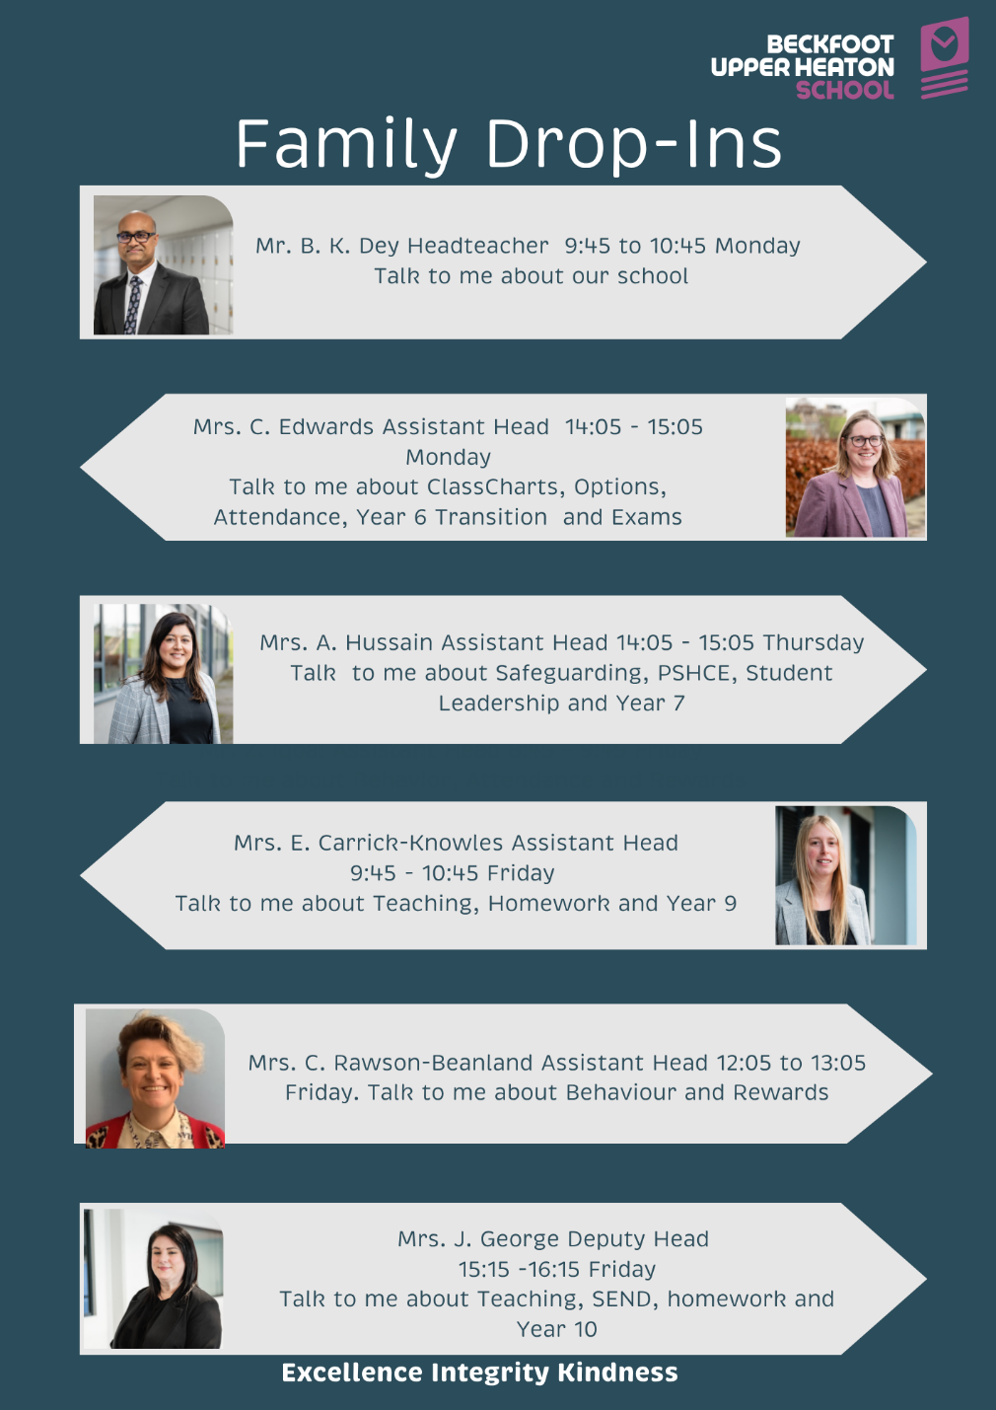

- Pupil and Family Induction and Reinduction

After every half-term there is a reset day planned for every year group to re-establish our 5 learning habits. Reset days may include assemblies, morning meetings, or bespoke interventions.

To ensure that no child is left behind, after the Christmas and Easter holidays all students will have the opportunity for a fresh start. Reward points will be reset to 1000.
Family partnerships are very important to us. To enable us all to work together, in the best interests of every child, we have clearly set out the role of the school and the role of the family. Please see the home-school agreement link below.

Home School Agreement.docx

We believe that feedback from families plays a critical role in driving our school’s improvement. We therefore collect the views of our families at our five consultation evenings and through our annual family survey.

All data collected is used to improve our students’ experience at school. We will give feedback to all stakeholders through our “You said, we did” approach.

- Explicit Teaching and Promotion of Self-regulation Strategies

In addition to Section 2 and 4 (above), we recognise that some of our students will require additional support and intervention to develop self-awareness and self-regulation. For these students' reasonable adjustments may be made and shared with families and relevant staff. These students may also attend personalised interventions.

- Respect and understanding for families
We recognise that every family’s needs are different and may change over time. In such circumstances, we encourage families to keep us informed so that we can signpost appropriate support and better understand the needs of the child at that time.

- Consistent, fair and predictable staff
We train our staff to consistently and fairly apply the behaviour protocol. This creates a safe and predictable environment for our students. We regularly revisit our school sentence with all staff and students to ensure we understand our core purpose.

UPH Behaviour and SEMH Pathway

Universal Offer | Universal Offer Plus |  | Universal Offer Plus +
Available to All | Phase 1 of Pathway | Phase 2 of Pathway | Phase 3 of Pathway
Led by all staff | Lead by HOY, middle leader, HLTA | Led by SLT/Behaviour lead/SENDCo | Lead by HT/DHT/SENDCo
- Behaviour system (usual reward and consequences)  - Visual display of rules, rewards and consequences  - Positive framing and rule reminders  - Regular assemblies to teach about behaviour  - Behaviour curriculum  - Parent/Carer communication via planners, Class Charts, phone calls, letters and meetings  - PSHE curriculum  - Belonging curriculum (for all KS3)  - Morning Meetings  - Allocated form tutor as key adult in school  - Attendance support  - Clear and timely communication regarding changes  - Strong admission and transition process and information sharing  - Reflective and Restorative approach | - Voice of the child to explore possible triggers, ACEs and barriers, RAG of timetable (HOY led)  - Monitoring Card (Positive)  - Voice of the family (HOY led)  - HOY monitoring and check-ins  - Peer mentoring  - Reset placement followed by reset meeting  - Low level self-regulation strategies  - Personalised communication of changes  - Phase 1 TAC  - Creation of PSP 1 (pastoral support plan) during TAC meeting based on revisit of child and family voice | - More frequent family contact  - Bespoke reward programme  - Information gathering to establish if any SEND e.g. book look, observation  - SEND screening/  assessment  - Sensory profile completed  - Sensory/Regulation breaks with a key adult  - Emotion coaching  - Support for unstructured time  - Bespoke SEMH interventions e.g. zones of regulation, circle of friends, social stories, lego therapy  - Bespoke Morning Meeting Groups  - Referral to Nurture Provision  - Reasonable adjustments to timetable  - Risk assessment  - Referral to external services (SEND, MHST, SCIL team, SALT, EP)  - Suspension followed by reintegration meeting  - Phase 2 Team Around the Child (TAC) meeting  - Creation of PSP 2 (pastoral support plan) during TAC meeting based on revisit of child and family voice  - Early Help referral  - LSC Board Panel | - Phase 3 TAC review meeting  - Review and amendments to PSP  - Further referrals or re-referrals to external services  - Risk assessment  - Reasonable adjustments to timetable  - Pupil Disciplinary Committee (PDC)  - OSD (Off-site direction)  - Application for EHCP  - Emergency EHCP review  - Permanent exclusion

Appendix: Supporting Information for Local Behaviour Protocol Beckfoot Upper Heaton

A. Key Terms and Definitions
Term | Definition
C1–C6 Codes | A graduated system of consequences based on behaviour, ranging from verbal warnings (C1) to serious sanctions (C6) such as suspension or exclusion.
R&R (Restoration and Reflection) | A designated space for students to reflect on their behaviour following a serious incident or refusal to engage with correction processes.
ATL (Attitude to Learning) | A numerical score (typically 1-4) reflecting a student's approach to learning, including effort, behaviour, and engagement.
SLT (Senior Leadership Team) | School leaders responsible for overall strategic and operational management, including behaviour and culture.
HOY (Head of Year) | A pastoral lead for each year group, responsible for student welfare, progress, and behaviour.
TAC (Team Around the Child) | A collaborative group of professionals and family members that supports a child with additional needs.
PSP (Pastoral Support Plan) | A personalised plan outlining specific support strategies for a student at risk of exclusion or ongoing behavioural challenges.
OSD (Off-site Direction) | A behaviour strategy involving temporary placement at another provision to support behaviour reform and reintegration.
EHCP (Education, Health and Care Plan) | A legal document for students with special educational needs, detailing required support across health, education, and care.

B. Uniform Clarification Visuals (available on request)
The Beckfoot Upper Heaton student uniform expectations are:

- Plain black leather/ leather look shoes or trainers (see photos or ask if unsure)
- Plain black trousers with a button and zip fastening. They should be either a loose fit or a tailored fit that covers their legs entirely (no flesh should be visible) – they should not be elasticated or have logos or patterns on them. No jeans/leggings or joggers.
- School tie
Year 7 – Purple
Year 8 – Blue
Year 9 – Orange
Year 10 – Maroon
Year 11 – Black
- Plain white, collared shirt with a fastening top button
- School blazer with school logo on
- An optional plain, black V-neck jumper which is never to replace the blazer
- Plain socks that fully cover the ankle
- Students should wear their uniform with pride and always have their shirts tucked in, their top buttons fastened and an appropriately fastened tie.

We expect that all students travelling to and from school will uphold the same standards

Outer coats: Outer coats should be of a style suitable for school and must not be worn inside the school building. All forms of outdoor clothing must be removed at the door.
Religious considerations: religious headwear can be worn in either black or white.
Bags: The bag should be of a size which can transport a PE kit, school books, pencil case, planner and a knowledge organiser (A4 size).
Piercings: Students may wear one small set of studs in their ear lobes and one discreet nose stud. No other piercings are allowed for health and safety reasons. Please note, all piercings should be removed during PE lessons and other practical subjects. No other jewellery is permitted.
Watches: Students may wear a watch however, smart watches are not allowed in school and will be confiscated if seen or heard.
Make-up: Must be natural and minimal, students will be provided with wipes and be expected to remove excessive make-up.
Nails: Acrylic extensions, gel and nail varnish are not to be worn. Students will be asked to remove them.
False eyelashes: False eyelashes are not permitted. Students will be provided with the opportunity to remove them.
To support consistent application of uniform expectations, visual guides and examples of acceptable attire (e.g., trousers, shoes, outerwear) are available from reception or on the school website.

C. Communication Channels for Families
Method | Purpose
ClassCharts App | Real-time behaviour tracking, rewards, and messages.
Family Drop-ins | Informal meetings to address concerns or share feedback.
Consultation Evenings | Formal opportunities for progress updates and shared goal-setting.
Annual Family Survey | Collecting feedback on the school’s culture and climate.
You Said, We Did Reports | School responses to family feedback, ensuring transparency and action.

D. Reasonable Adjustments Protocol
All behaviour expectations are applied fairly and inclusively. However, adjustments may be made based on individual needs such as:
- Diagnosed SEN (e.g., ADHD, Autism)
- Medical conditions
- Temporary family or personal challenges
- Cultural or religious practices
These are managed through personalised support plans, risk assessments, or temporary amendments to routines, agreed upon with the SENDCo, pastoral staff, and families.

E. R&R Room Process Overview
- Initial Entry – Student collected by On-Call or SLT.
- Check-In – Incident logged, expectations clarified, mobile phones/electronic items are handed over for storage
- Reflection Work – Student completes a reflection sheet and missed learning tasks/ retrieval tasks.
- Staff Check – HOY or SLT reviews behaviour and readiness for reintegration.
- Exit & Follow-Up – Re-entry plan discussed with student and (if appropriate) family.

F. Additional Resources
- Home–School Agreement – [please see above]
- Beckfoot Trust Behaviour Policy – [Available at: https://www.beckfoottrust.org/policies]
- Parent Guidance on ClassCharts – [Available on school website or via pastoral office]
- Attendance Policy – [Available at: Policies – Beckfoot Trust ]

